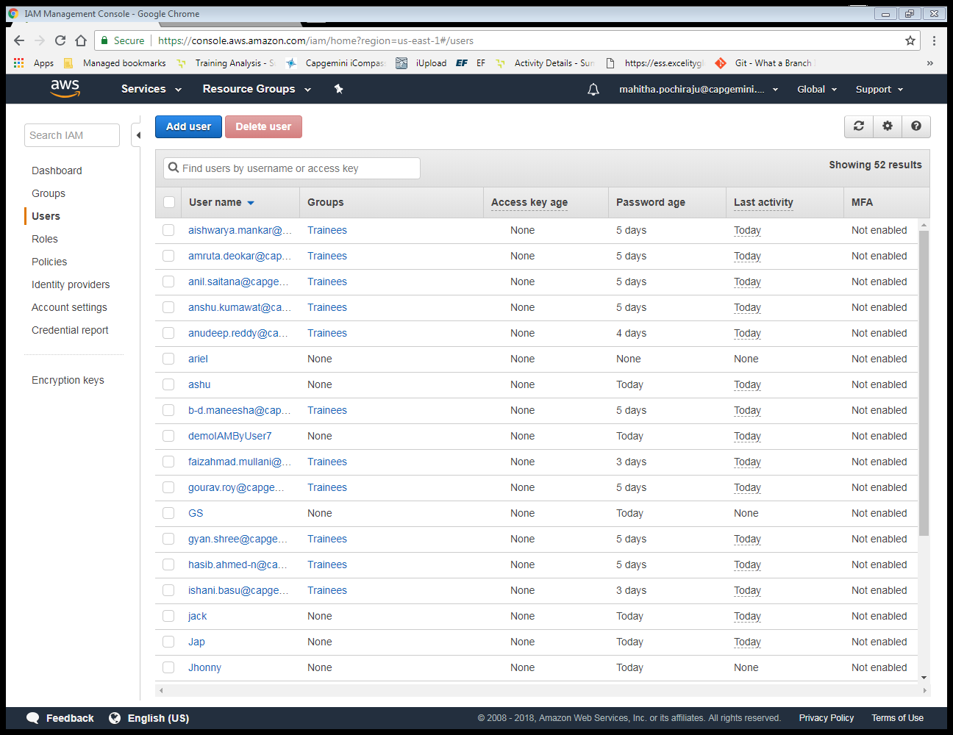

Follow the Steps to create a user by using IAM service

Step 1: Choose the IAM service in AWS

Step 2 : Click on User link in IAM dashboard and click on AddUser button

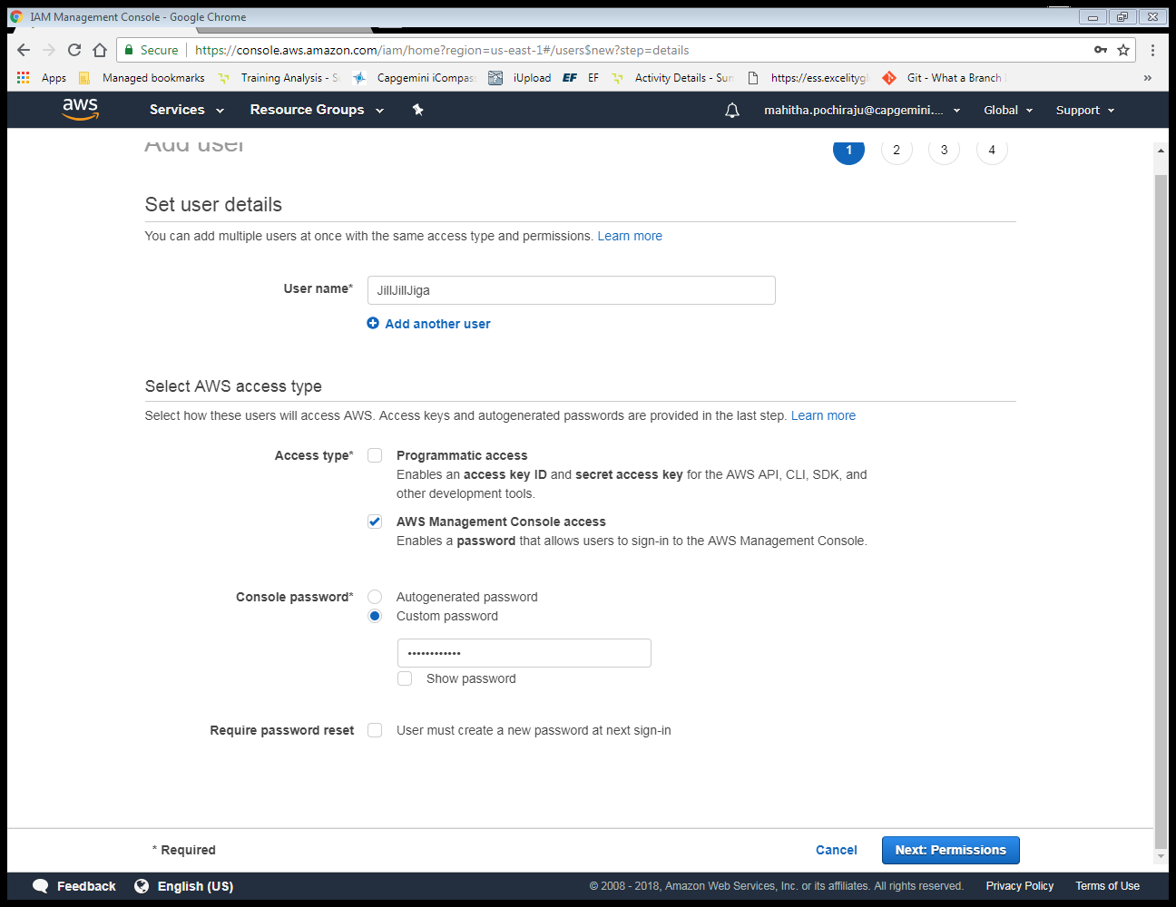

Step 3 : Type a user name and choose the access type

Step 4 : Select custom password and provide a password .( it must contain at least 12 characters and it must contain a digit )

Step 5 : click on Next permission button.

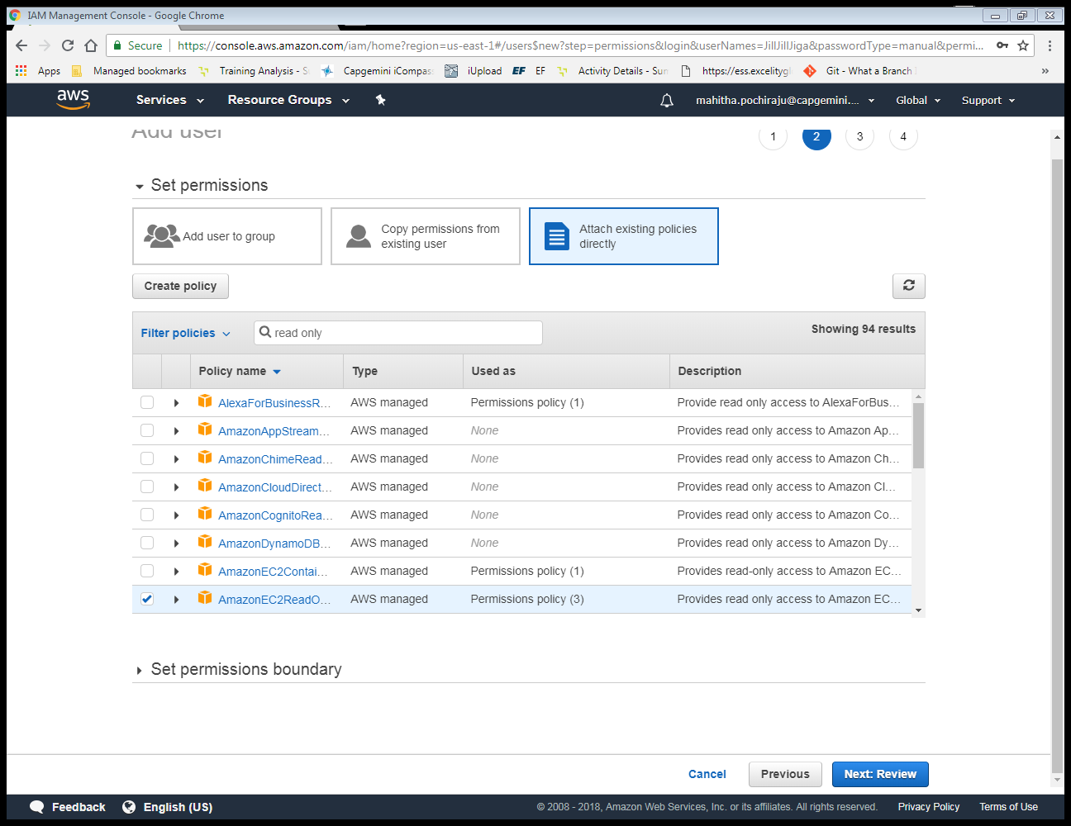

Step 6 : Click on Attach existing ploicy button directly

Step 7 : Select AmazonEC2ReadonlyAccess checkbox from existing list and click Next:review button.

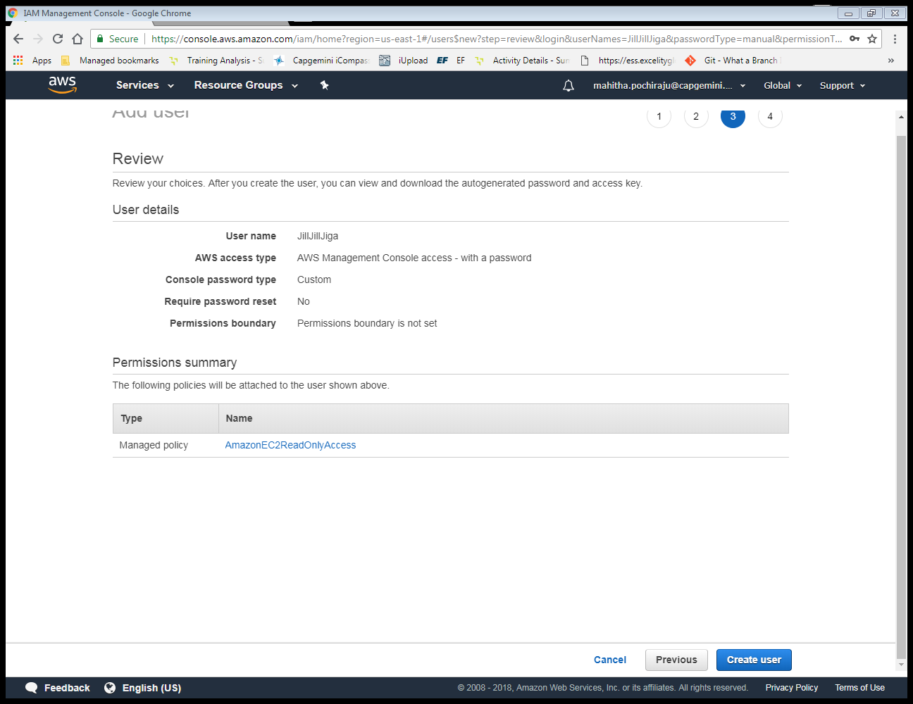

Step 8 : click on create user button .

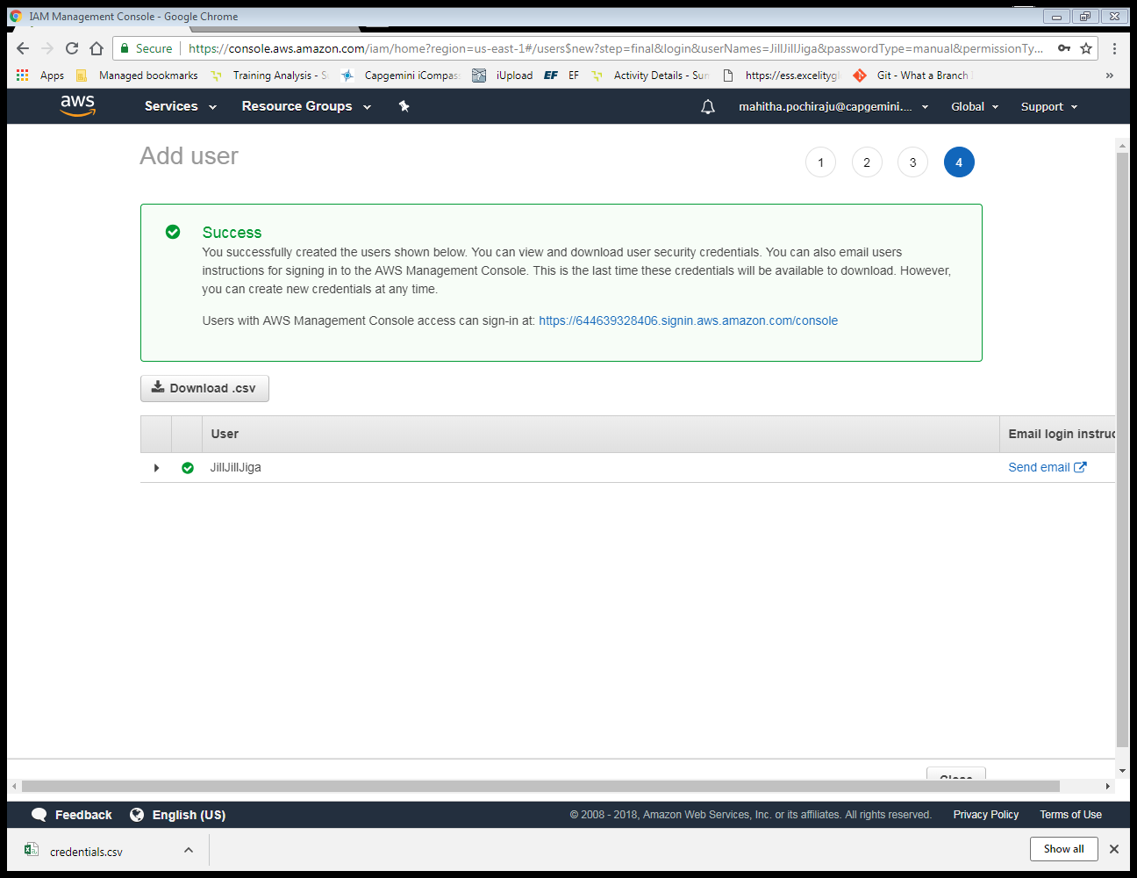

Step 9 : Now download the credential in .csv format and click on close button.

Step 10 : Click on user link and review the policy.

Follow the Steps to create a policy for your Ec2 instance which you have created before.

Step 11 : Click on Policy link in IAM dashboard

Step 12 : Click on createpolicy button

Step 13 : Choose EC2 service.

Step 14 : Click on Select action link and choose List and read checkbox

Step 15 : Select resources and choose specific option

Step 16 : Click on Add ARN link

Step 17 : click on Add button

Step 18 : click on review policy button

Step 19 : click on Add permission link

Step 20 : choose IAM service

Step 21 : select Action and expand Write option

Step 22 : choose checkbox “Update Login Profile”

Step 23 : Now choose specific resources and add ARN

Step 24 : Click on review policy button

Step 25 : click on create policy button

Step 26 : go to user and select the user you created before

Step 27 : detach the previous policy

Step 28 : Add the policy you created before

Step 29: click on Next review button

Step 30 : check the new policy attached to user

Steps to allow the user top signin and see the restrictions

Step 31 : Go to browser and add the user name and password and login

Step 32 : Select EC2 service and see all the instances.

Step 33 : Choose your instance and try to stop it.